AFFIDAVIT OF IDENTITY THEFT
I, Debrea Elaine Young Dunham, being of lawful age and competent to testify, declare under penalty of perjury that I am the individual whose personal identifying information is referenced in this affidavit, that I have personal knowledge of the matters stated herein except where otherwise indicated, and that this affidavit is submitted to document identity theft, unauthorized use of my personal identifying information, and disputed items appearing in consumer reporting and related records.
Declaration
I declare that the statements set forth below are true and correct to the best of my knowledge, information, and belief. I have repeatedly requested that soft and hard inquiries be removed from my profile, but each bureau has the conveyance that “it is typical to see small variations in reported personal information like names and addresses and that soft inquiries do not affect your credit score or profile.” However, ambiguity within this data allows multiple credit profiles that belong to the same person to have hidden accounts with identical account numbers from the same creditor with mis-matching information such as balance and payment history which is different at each bureau and is directly related to the real name true-identity theft I am experiencing.
Throughout this affidavit will show accounts with disparate information from different profiles with data that has changed overtime from each credit report summary or dispute results report.
Except where expressly identified as authorized by me, the addresses, aliases, accounts, inquiries, and related activity described in this affidavit were not initiated, opened, authorized, or benefited by me.
Statement of Facts
- I have been identified by other credit bureaus as a victim of real-name true-identity theft by Equifax, Transunion, and Consumerinfo.COM. I dispute every name other than Debrea Elaine Young Dunham and addresses other than 927 SW 35th Street Lawton, OK or 1316 NW Sheridan Road Lawton, OK 73505, Social Security Variation, Employer, Collection and other records listed in any bureau.
- The address 925 SW 35th Street, Lawton, Oklahoma 73505, should not be associated with my profile. 1316172 NW SHERIDAN LAWTON OK, 73505 is an invalid address as noted internally by Experian and does not appear on any other bureau and was used to open fraudulently unbeknownst to me.
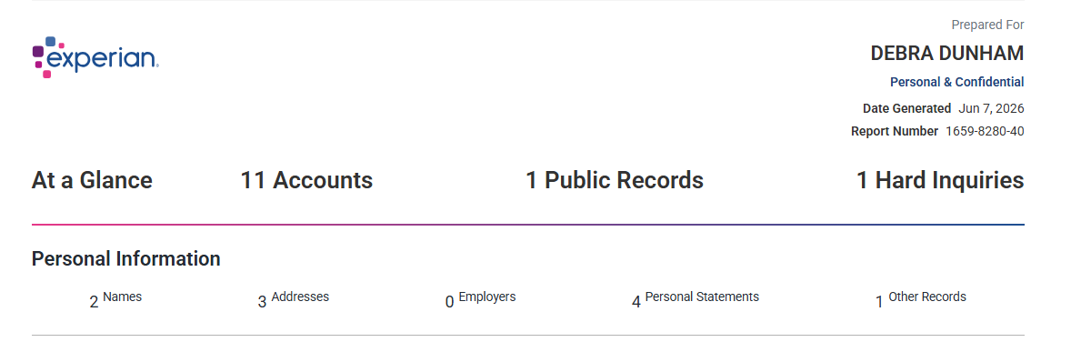
- I did not open, authorize, apply for, use, posses benefit from, or make charges on any such unauthorized account(s). I did not give permission to any person or entity to use my name, Social Security Number or variation thereof, date of birth, address, or any other identifying information to obtain credit cards, loans, or lines of credit, or any other financial benefit thereof. Any account, application, inquiry, address, or transaction associated with these activities were made by an unauthorized person.
  - CAPITAL ONE-515676XXXXXX-$3,174.00
  - CAPTIAL ONE - 517805XXXXXXXXXX -$307.00
  - CCS/FIRST NATIONAL BANK - 423980XXXXXXXXXX – NO STATUS
  - FB&T MERCURY - $3,830.00
  - FIRST INV SERVICING CORP - 500001XXXXXXXXXXX - $18,258.00
  - FORT SILL FED CR UN - 272686XXXX - $2,000.00
  - TIDEWATER MOTOR CREDIT - $26,980.00
- As of 6/7/2026, The name Debra Dunham has re-appeared on my Experian report. The name Debra Young Dunham is now also showing on latest “dispute results”, while Debra Elaine Young Dunham which is my real name and true-identity is missing and does not show on the shows on the “Print Your Report” or Dispute Results. Every alias is fraudulent along with the accounts listed within that profile and needs to be removed and updated to reflect one identity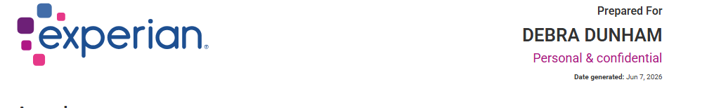.
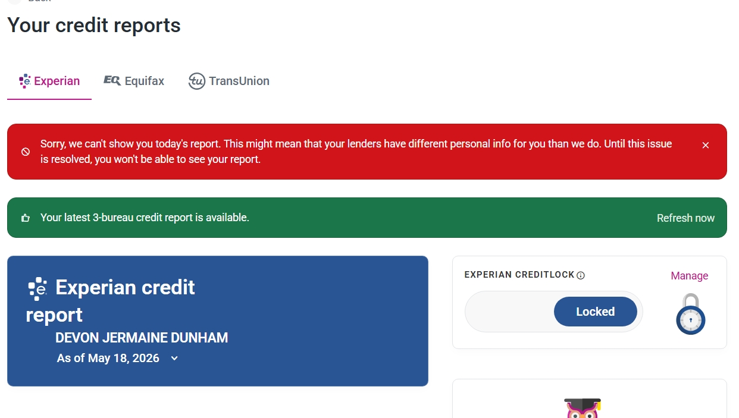

Relief Requested
- I request that all consumer reporting agencies, furnishers, creditors, and other relevant entities promptly block, remove, suppress, synchronize or otherwise cease reporting any account, tradeline, inquiry, alias, address, phone number, or other identifying information that is unauthorized, inaccurate, unverifiable, or the product of real name true-identity theft.
- I request correction and deletion of all disputed personal identifying information, including aliases, addresses, employers, collections, and contact information that do not belong to me or were associated with my profile without my authorization.
- I request a reasonable investigation and written validation from each entity that accessed, used, furnished, or relied upon my personal identifying information, including the basis for each inquiry, account opening, tradeline, or report entry reflected in the records attached to this affidavit.
- I request that any collection, servicing, lending, foreclosure or delinquent reporting activity related to disputed or unauthorized accounts be suspended or blocked pending investigation and resolution.
- I request written confirmation of all corrections, deletions, blocks, suppressions, fraud flags, and other remedial actions taken in response to this affidavit.
- I further request any other relief, protection, or corrective action available under applicable law to prevent additional misuse of my identity and to restore the accuracy of my consumer and related records.
- I respectfully request and attest that any creditor, consumer reporting agency, furnisher of information, investigator, or other recipient of this affidavit promptly investigate this matter, block and remove the fraudulent accounts noted above, cease reporting inaccurate information arising from identity theft, update my real name so that it reflects as it should, and provide any relief available under applicable law. I further request that any records reflecting unauthorized inquiries, applications, accounts, balances, or delinquencies related to this identity theft be corrected or deleted. Last, all profiles with suffix social security numbers ending in 8006 and 5527 need to be prevented from applying to credit scores on freeannualcreditreport.com by simply switching the numbers from the suffix of my social security number.
Attestation
Further affiant sayeth not. I declare under penalty of perjury that the foregoing statements are true and correct to the best of my knowledge, information, and belief.
Executed on ____________________, 2026, at 4:44:35 PM
__________________________________
Debrea Elaine Young Dunham, Affiant
Subscribed and sworn to before me on ____________________, 20____.
__________________________________
Notary Public
My commission expires: ____________________

